


DEPARTMENT OF COMPUTER SCIENCE AND ENGINEERING

OBJECT ORIENTED PROGRAMMING LABORATORY (CS P43)

B. Tech – IV SEMESTER

STUDENT NAME: MOHAMED B SIRAJUDDEEN
REGISTER NO: 22TD0053

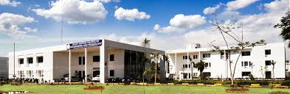


RAJIV GANDHI COLLEGE OF ENGINEERING AND TECHNOLOGY
(Approved by AICTE and Affiliated to Pondicherry University)
ISO 9001:2015

PUDUCHERRY – 607 403
MAY 2024

